**NATIONAL UNIVERSITY OF SCIENCES & TECHNOLOGY**

**MILITARY COLLEGE OF SIGNALS**



**COMPUTER NETWORKS**

**(EE-353)**

**LAB PROJECT DOCUMENTATION**

**Submitted by:** **MUHAMMAD AHMAD SULTAN**

**CMS ID**: **408709**

**R**ANK: **NC**

**C**OURSE: **BESE-28**

**S**ECTION: **C**

**Submitted to:** **Sir Zohaib Ali**

***D****ated:*01-02-2024

CATALOG OF THE LAB PROJECT

Table of Contents

* Title of the Lab Project03
* About Me04
* Abstract05
* History of the Chatting Applications05
* Objective06
* Scope07
* Beyond Current Focus08
* Functionality & Implementation09
* MySQL Schema09
* Java Classes11
* Input and Output Specifications16
* OOP Principles & Concepts17
* Software/Equipment Used18
* Execution & Output 19
* Display20
* Project Timeline, Budget, Team23
* Future Enhancements23
* Potential Questions25
* Conclusion26
* Reference Citations26

**DEPARTMENT OF COMPUTER SOFTWARE ENGINEERING**

**Military College of Signals**

**National University of Sciences and Technology**

[**www.mcs.nust.edu.pk**](http://www.mcs.nust.edu.pk)

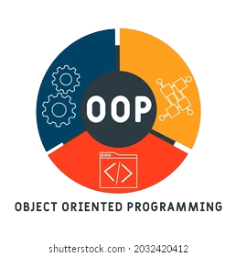

**T**ITLE **O**F **T**HE **L**AB **P**ROJECT

**TalkBuddy NetNexus**

***An Object-Oriented Java Swing Chatting Application with Socket Programming for Seamless Server-Client Communication and Dynamic Group Chatting & Interaction as well as One-on-One Private Chatting & Interaction.***

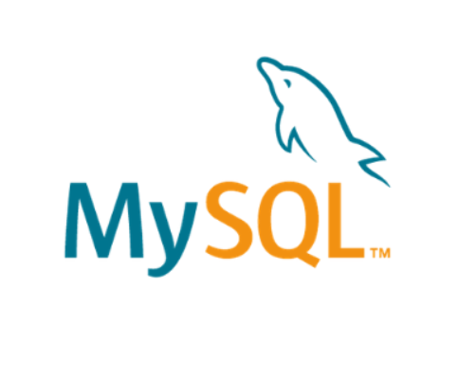

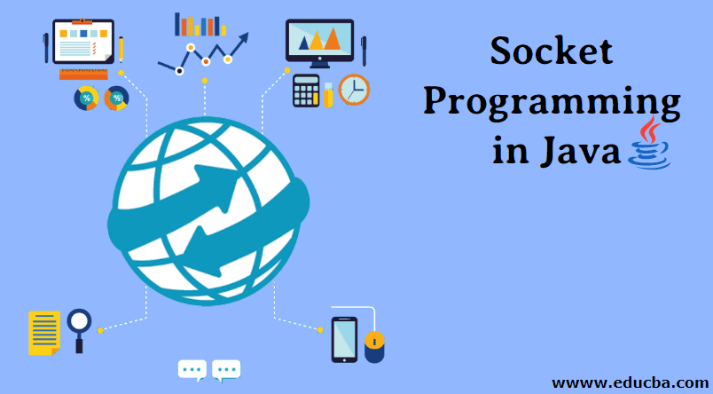

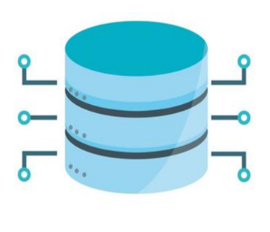

About me



Allow me to introduce myself. I am *Muhammad Ahmad Sultan*, a highly motivated second-year student at the ***Military College of Signals***, currently pursuing a **Bachelor's degree in Software Engineering**. With unwavering determination, I am committed to achieving my goals and making significant strides in my academic journey.

**Muhammad Ahmad Sultan**

Developer

* Abstract:

TalkBuddy NetNexus is a Java-based chat application developed using Java Swing, Java AWT, Socket Programming, and MySQL Workbench. The application provides users with a comprehensive chatting experience, featuring a splash window for project identification, user authentication via a MySQL database, one-on-one private chatting between a server and a client, and dynamic group chatting functionality. Leveraging multithreading concepts, the server facilitates seamless communication by broadcasting messages from one user to all connected clients. With its user-friendly interface and robust communication architecture, TalkBuddy NetNexus ensures a secure and responsive platform for real-time individual and group interactions. Whether engaging in private conversations or participating in group discussions, TalkBuddy NetNexus delivers a seamless and enjoyable chatting experience, fostering meaningful interactions in real-time.



* History of the Chatting Applications:

Late 1960s and early 1970s: The development of computer networks like ARPANET laid the groundwork for the creation of the first online chat systems.

1971: Douglas Engelbart developed the "On-Line System" (NLS), which included a message group chat feature, marking one of the earliest instances of collaborative online communication.

1990s: Internet Relay Chat (IRC) emerged as a popular real-time communication protocol, facilitating text-based chat rooms and private messaging.

Late 1990s: The late 1990s saw the rise of instant messaging applications such as ICQ, AIM (AOL Instant Messenger), and MSN Messenger, which revolutionized online communication by enabling real-time text-based conversations between users.

Early 2000s: The early 2000s witnessed the introduction of voice and video chat capabilities with platforms like Skype and Google Talk, further enhancing the richness of online communication by incorporating audio and video elements.

Today: Platforms like WhatsApp, Facebook Messenger, and WeChat dominate the mobile chat app market, offering a wide range of features including text messaging, voice and video calls, group chats, multimedia sharing, and more, catering to the evolving needs of users in the digital age.

* 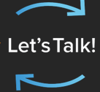Objective:
* **Real-time Communication Enhancement:**

Implement mechanisms for real-time message exchange, ensuring minimal latency and delay using technologies like web sockets.

* **Comprehensive Chatting Application Development:**

Create a dedicated application supporting conversations with user-friendly features such as a splash window, user authentication, one-on-one private chatting, and dynamic group chatting.

* **Enhanced User-to-User Messaging:**

Enable direct communication between users with a robust messaging system that handles message routing securely and reliably.

* **Group Chatting with Multithreading:**

Implement multithreading concepts to facilitate group chatting, allowing the first user (client) to send messages to the server for broadcast to all other users (clients) in real-time.

* **Message Delivery and Receipt Assurance:**

Ensure successful message delivery and receipt tracking with features like message acknowledgment, delivery status notifications, and read receipts.

* **Text-based Communication Support:**

Enable users to exchange text-based messages seamlessly, incorporating text input fields, message composition features, and proper rendering in the user interface.

* **Intuitive User Interface Design:**

Design an intuitive and visually appealing interface with organized conversations, clear user presence indicators, and features like search, filters, and notifications for enhanced user experience.

* **Robust Client-Server Architecture Implementation:**

Develop a server-side component for efficient message routing, user authentication, and data storage, ensuring synchronization of chat history across devices.

* **Effective Socket Programming Utilization:**

Utilize socket programming techniques to establish and manage network connections, enabling bidirectional communication for real-time message exchange.

* **Message Formatting and Display Optimization:**

Implement proper formatting and rendering of messages to enhance readability and user experience, handling special characters, emojis, and formatting styles effectively.

* **User Authentication:**

Incorporate user authentication mechanisms using a MySQL database to verify user credentials, ensuring secure access to the chat application.



* Scope:
* **User Authentication:**

Implement a secure user authentication system using a MySQL database to verify user credentials, ensuring only authorized users can access the application.

* **Private Chatting:**

Enable one-on-one private chatting between users, displaying messages with timestamps to indicate sending and receiving times, ensuring real-time communication.

* **Group Chatting:**

Implement group chatting functionality, allowing multiple users to participate in dynamic group discussions with messages timestamped for sending and receiving times.

* **Splash Window:**

Design and integrate a splash window to display project identification, description, and developer information, enhancing the application's visual appeal.

* **Real-time Communication:**

Utilize efficient socket programming techniques to establish and maintain real-time communication channels between the server and clients, minimizing latency.

* **Message Delivery Confirmation:**

Implement features to track and confirm the successful delivery of messages, providing users with acknowledgment of sent messages and read receipts.

* **User Interface Enhancement:**

Design a user-friendly interface with organized conversation threads, clear indicators of user presence, and intuitive message composition features for an enhanced user experience.

* **Error Handling:**

Implement error handling mechanisms to gracefully manage unexpected errors or network interruptions, ensuring the application's stability and reliability.

* **Multithreading for Group Chat:**

Utilize multithreading concepts to efficiently handle group chatting, allowing the server to broadcast messages from one user to all connected clients in real-time.

* **Timestamped Messages:**

Ensure all messages sent and received by users are timestamped to provide a clear indication of when the message was sent and when it was received, enhancing message organization and clarity.

* Beyond Current Focus:
* **Audio and Video Calls:** This feature allows users to have real-time audio and video communication within the chat client. Users can initiate voice or video calls with their contacts, enabling more interactive and immersive conversations.
* **Artificial Intelligence-based Features:** By leveraging AI, the chat client can offer advanced features such as smart replies, chatbot integration, intelligent chat moderation, and automated content filtering. AI algorithms can analyze conversations, understand user preferences, and provide personalized recommendations or automated actions.
* **Voice Messaging:** Voice messaging enables users to send and receive recorded audio messages within the chat client. It provides an alternative communication method, allowing users to express themselves using their own voice and adding a more personal touch to the conversation.
* **Multiple Language Support:** This feature enables users to communicate in different languages within the chat client. It includes language translation capabilities that can automatically translate messages between different languages, facilitating communication between users who speak different languages.
* **File Transfer:** File transfer functionality allows users to share files (e.g., documents, images, videos) with their contacts directly through the chat client. It provides a convenient way to exchange files without the need for external file-sharing platforms or email attachments, enhancing collaboration and productivity.

**Note:**

It's important to note that while these features are interesting and may enhance the chatting application, they require additional development time, resources, and expertise. Therefore, if you're working on a project with a specific scope and timeline, it's important to prioritize and focus on the core features that align with the project's objectives

* TalkBuddy NetNexus

**Functionality & Implementation**

* **Splash Window (MainWindow.java)**

The splash window provides an introductory interface displaying the project name, description, and developer name.

**Implementation:**

* ***MainWindow.java:*** Implements the splash window using Java Swing components.
* **User Authentication (Login.java, dbConnectivity.java)**

User authentication enables users to log in using their username and password stored in a MySQL database.

**Implementation:**

* ***Login.java:*** Manages the user interface for login functionality.
* ***dbConnectivity:*** Establishes JDBC connection with MySQL Workbench to verify user credentials.
* ***MySQL Schema:***

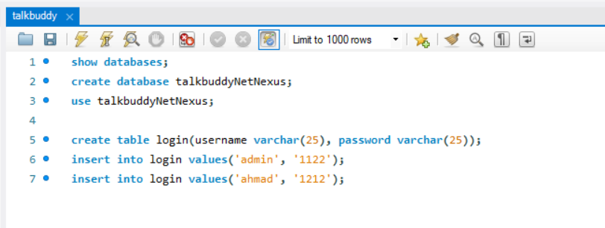

* **One-on-One Private Chatting (Server.java, Client.java)**

Enables private messaging between a server and a client.

**Implementation:**

* ***Server.java:*** Handles server-side communication for private chatting.
* ***Client.java:*** Manages client-side communication for private chatting.
* **Group Chatting (ServerBroadcast.java, FirstUser.java, SecondUser.java, ThirdUser.java)**

Facilitates group messaging where messages from one user are broadcasted to all other users.

**Implementation:**

* ***ServerBroadcast.java:*** Handles broadcasting messages from one client to all other clients.
* ***FirstUser.java, SecondUser.java, ThirdUser.java:*** Represent individual client threads for group chatting.
* **Multithreading for Group Chatting**

Utilizes multithreading concepts to handle simultaneous group chat messages efficiently.

**Implementation:**

ServerBroadcast.java, FirstUser.java, SecondUser.java, ThirdUser.java: Implement multithreading to manage concurrent messaging.

* **Socket Programming**

Enables real-time communication between server and clients.

**Implementation:**

Utilizes Java Socket Programming for establishing connections and transmitting messages.

* **MySQL Database Management**

Manages user credentials and authentication using a MySQL database.

**Implementation:**

Utilizes MySQL Workbench for database creation and management.

Implements JDBC connectivity in Java for interacting with the database.

* **Graphical User Interface (GUI)**

Provides a user-friendly interface for interacting with the application.

**Implementation:**

Utilizes Java Swing and Java AWT for designing and implementing the GUI components.



* Java Classes
* ***MainWindow.java***

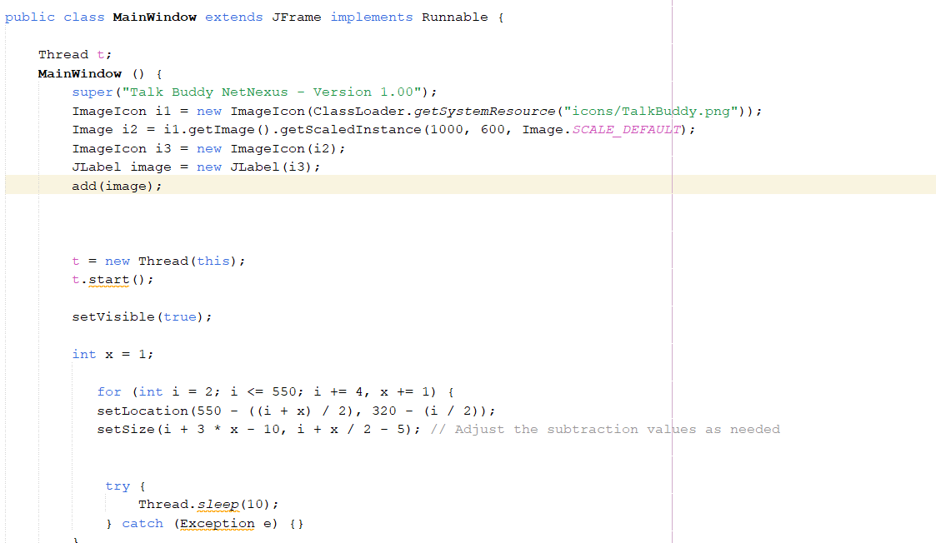

**Purpose:**

* Displays a splash window showing project name, description, and developer name.

**Functions:**

* Initialize and display the splash window.
* Set project name, description, and developer name.
* Handle window closing events.
* ***dbConnectivity.java***

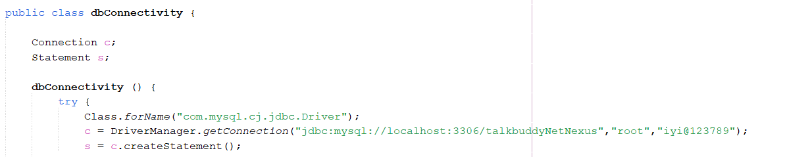

**Purpose:**

* Establishes JDBC connection with MySQL Workbench database for user authentication.

**Functions:**

* Establish database connection using JDBC.
* Execute queries to validate user credentials.
* Handle database connection errors.
* ***Login.java***

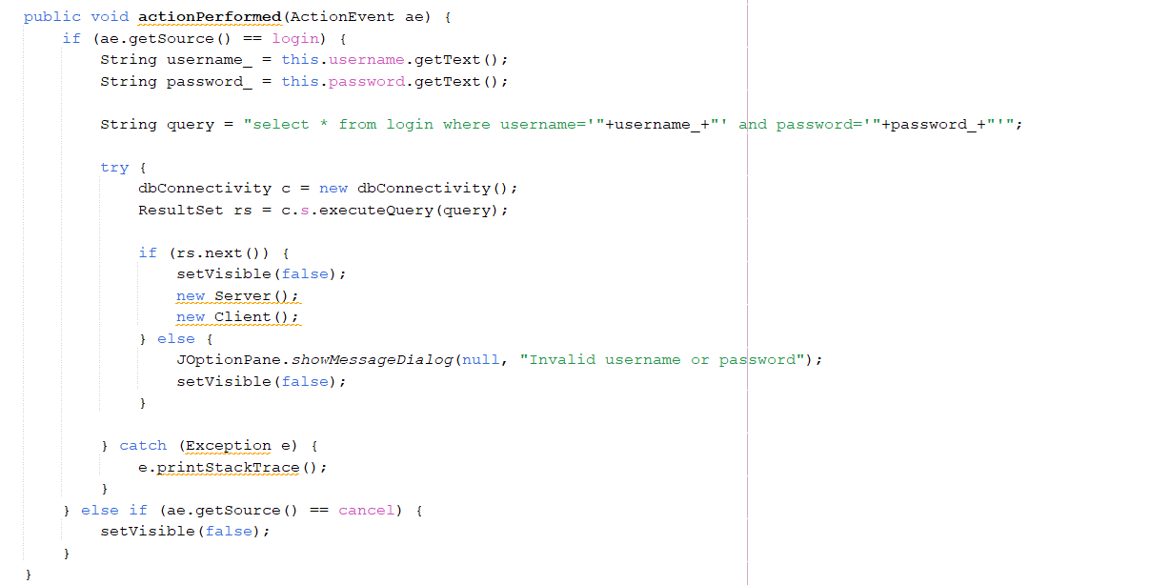

**Purpose:**

* Handles user authentication using username and password stored in the MySQL database.

**Functions:**

* Display login interface.
* Validate user credentials using dbConnectivity.
* Handle login success and failure events.
* ***Server.java***

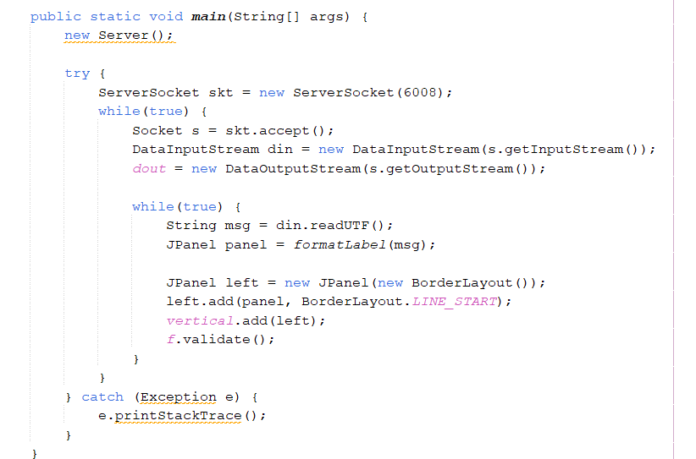

**Purpose:**

* Manages one-on-one private chatting between server and client.

**Functions:**

* Initialize server socket and accept client connections.
* Manage client-server communication for private chatting.
* Handle disconnection events.
* ***Client.java***

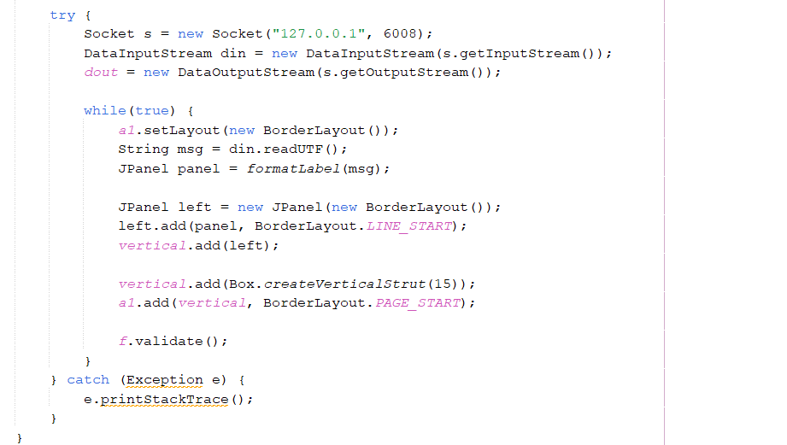

**Purpose:**

* Represents a client for one-on-one private chatting.

**Functions:**

* Connect to the server.
* Send and receive messages to/from the server.
* Handle disconnection events.
* ***ServerBroadcast.java***

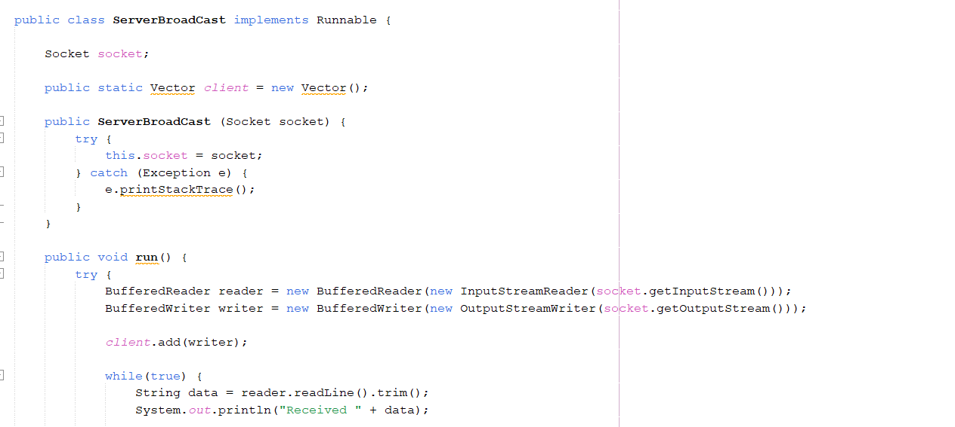

**Purpose:**

* Manages group chatting functionality by broadcasting messages from one client to all other connected clients.

**Functions:**

* Receive messages from the first user (client).
* Broadcast messages to all other users (clients).
* ***FirstUser.java, SecondUser.java, ThirdUser.java,……..***

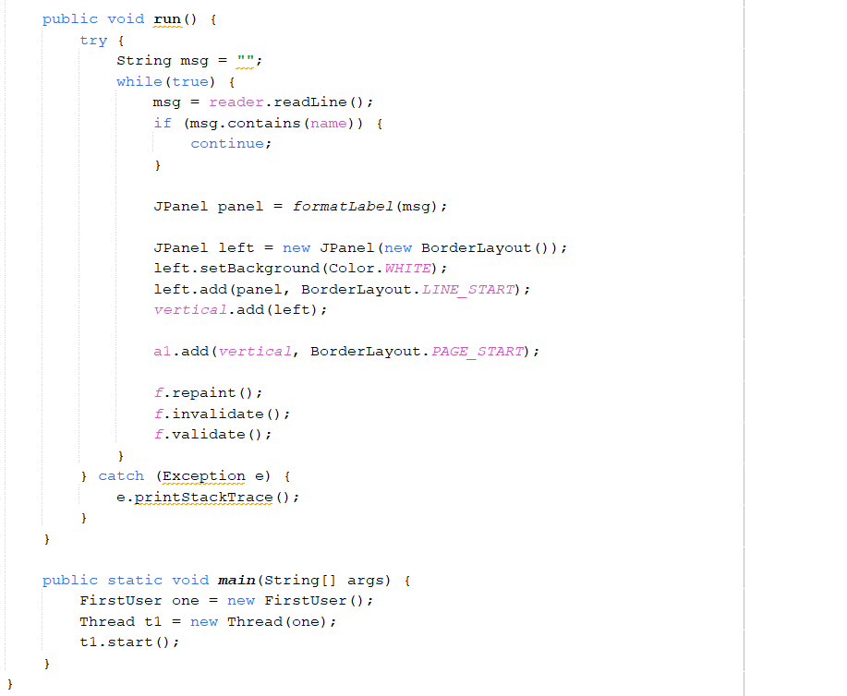

**Purpose:**

* Represents individual users in the group chat.

**Functions:**

* Receive and display messages from the server.
* Send messages to the server.
* Input and Output Specifications
* **Input Specifications:**
* **Username and Password:**

Input from the user during the login/authentication process.

* **Chat Messages:**

Input from users for one-on-one private chatting or group chatting.

* **Commands (for server):**

Input commands to start, stop, or manage the server's functionality.

* **Output Specifications:**
* **Splash Window (MainWindow.java):**

Output: Display of project name, description, and developer name.

* **User Authentication (Login.java):**

Output: Successful or failed authentication message.

* **One-on-One Private Chat (Server.java and Client.java):**

Output: Exchange of private messages between two users.

* **Group Chat (ServerBroadcast.java, FirstUser.java, SecondUser.java, ThirdUser.java):**

Output: Broadcasting of messages from one user to all other connected users in the group.

* **Database Connectivity (dbConnectivity):**

Output: Connection status messages (success or failure) during database operations.

* **Overall Interaction:**
* **User Interaction:**

Users interact with the application through the graphical user interface provided by Java Swing and Java AWT components.

Users input their credentials for authentication and exchange messages during chatting sessions.

* **Server Interaction:**

The server manages communication channels, handles authentication requests, and facilitates message broadcasting for group chatting.

Server interacts with the MySQL database for user authentication and storage of login credentials.

* **Database Interaction:**

The application interacts with the MySQL database for user authentication purposes, validating login credentials provided by users.

* **Multithreading Interaction:**

Multithreading is utilized for efficient handling of multiple client connections and simultaneous message broadcasting in group chatting.

* **Usage of OOP Concepts in TalkBuddy NetNexus**
* **Classes and Objects:**

The TalkBuddy NetNexus chat application employs various classes like MainWindow, Login, dbConnectivity, Server, Client, ServerBroadcast, FirstUser, SecondUser, and ThirdUser.

Objects of these classes represent different functionalities within the chat application, such as the splash window, user authentication, database connectivity, server-client communication for one-on-one chatting, and multithreading for group chatting.

* **Inheritance:**

Inheritance establishes relationships between classes in TalkBuddy NetNexus.

For example, a base class like Server can be extended by subclasses like Client, ServerBroadcast, FirstUser, SecondUser, and ThirdUser to inherit common attributes and behaviors related to server-client communication.

* **Encapsulation:**

Encapsulation is a fundamental concept applied to classes in TalkBuddy NetNexus to encapsulate data and functionality securely.

For example, the Login class encapsulates user authentication details like username and password, providing methods to securely access and verify this information.

* **Method Overriding:**

Method overriding is implemented when custom implementations of inherited methods are needed in TalkBuddy NetNexus.

For instance, the sendMessage() method in the Server class can override the same method in a superclass to handle one-on-one private chatting, while the broadcastMessage() method in the ServerBroadcast class can override the same method to handle group chatting.

* **Constructor:**

Constructors are vital components in various classes of TalkBuddy NetNexus to initialize object properties during their creation.

For example, a constructor in the MainWindow class can be utilized to set initial values such as project name, description, and developer name, ensuring proper initialization of the splash window.

* **Polymorphism:**

Polymorphism is applied in TalkBuddy NetNexus to treat objects of different classes as instances of a common superclass or interface.

For flexibility and code reusability, methods that handle message transmission can accept both Server and Client objects, treating them as instances of a common ChatObject superclass.

* By leveraging these Object-Oriented Programming (OOP) principles, TalkBuddy NetNexus ensures a robust and maintainable codebase. This approach facilitates efficient communication and interaction within the chat application, promoting flexibility and scalability.
* Software/Equipment Used:
* **Software:**
* **Java Swing:** Utilized for developing the graphical user interface (GUI) of the chat application, including components like buttons, text fields, and windows.
* **Java AWT (Abstract Window Toolkit):** Used in conjunction with Java Swing for creating and managing graphical user interface components.
* **Socket Programming:** Implemented to establish communication channels between the server and clients for real-time messaging.
* **MySQL Workbench:** Utilized for database management, specifically for storing user authentication credentials (username and password) for login functionality.
* **JDBC (Java Database Connectivity):** Used for connecting Java applications, including your chat application, to the MySQL database for querying and updating data.
* **Networking libraries:** Employed for handling network communication between the server and clients.
* **Java Development Kit (JDK):** Essential for compiling and running Java code.
* **Integrated Development Environment (IDE):** Utilized for coding, debugging, and testing the Java application.
* **Operating System:** The application is compatible with various operating systems such as Windows, macOS, and Linux.
* **Hardware/Equipment:**

No specific hardware requirements are mentioned, ensuring flexibility in deployment across various computing environments and configurations.

* **Computer:** Required for development and running the Java-based chat application.
* **Input Devices:** Keyboard, mouse, etc., for interacting with the application.
* **Output Devices:** Monitor, speakers, etc., for displaying GUI elements and receiving audio output during chat sessions.
* **Output and Execution Flow in TalkBuddy NetNexus:**
* **Splash Window (MainWindow.java):**

Upon launching the application, a splash window is displayed, showcasing the project name, description, and developer information.

* **User Authentication (Login.java):**

Users are prompted to enter their username and password.

Upon successful authentication against the MySQL Workbench database, users gain access to the chat application.

Incorrect credentials prompt an error message, requesting users to re-enter their login details.

* **One-on-One Private Chatting (Server.java and Client.java):**

After successful authentication, users can engage in one-on-one private chatting with another user.

Messages are sent and received in real-time using Socket Programming.

The server mediates communication between clients, ensuring reliable message transmission.

* **Group Chatting (ServerBroadcast.java, FirstUser.java, SecondUser.java, ThirdUser.java):**

Users can initiate or join group chats with multiple participants.

The first user (client) sends messages to the server, which then broadcasts them to all other connected users using multithreading concepts.

Group chat messages are displayed in real-time to all participants, fostering interactive discussions.

* **Database Connectivity (dbConnectivity):**

Establishes JDBC connection with MySQL Workbench database for user authentication.

Enables the application to verify user credentials securely and efficiently.

* **Execution Flow:**
* Launch the application.
* Splash window appears, displaying project details.
* Enter username and password for authentication.
* Upon successful login, the main chat interface is displayed.
* Engage in one-on-one private chatting or initiate/join group chats.
* Messages are transmitted in real-time between users.
* Log out from the application to end the session.
* **Output:**
* Upon successful execution, users can seamlessly communicate via private or group chats within the application's user-friendly interface.
* Real-time message transmission ensures a dynamic and responsive chatting experience.
* User authentication adds a layer of security, preventing unauthorized access to the chat application.
* Output Display:
* 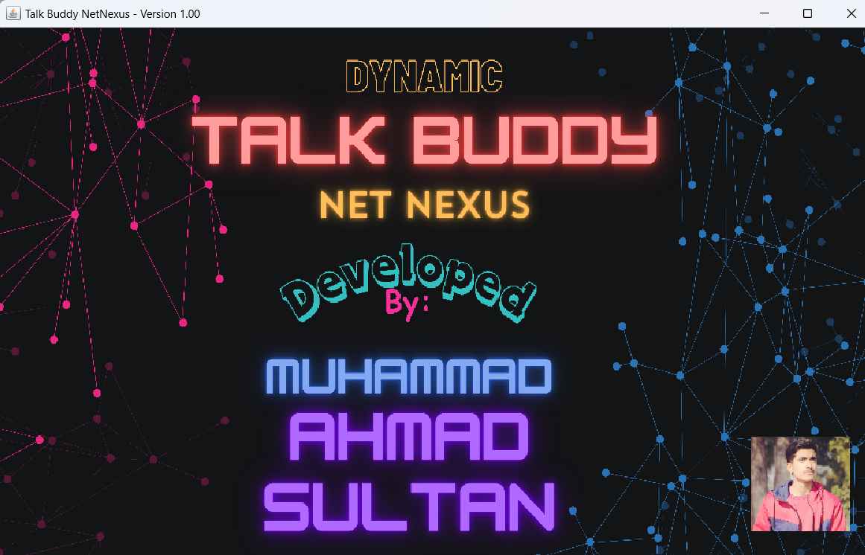***MainWindow.java***
* ***Login.java***

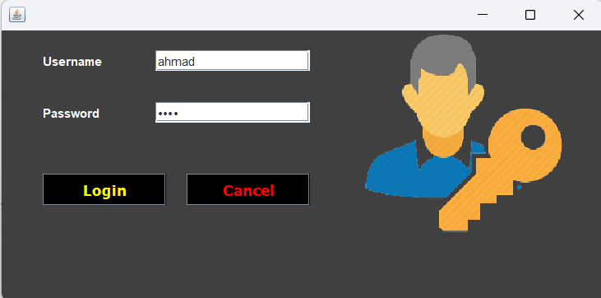

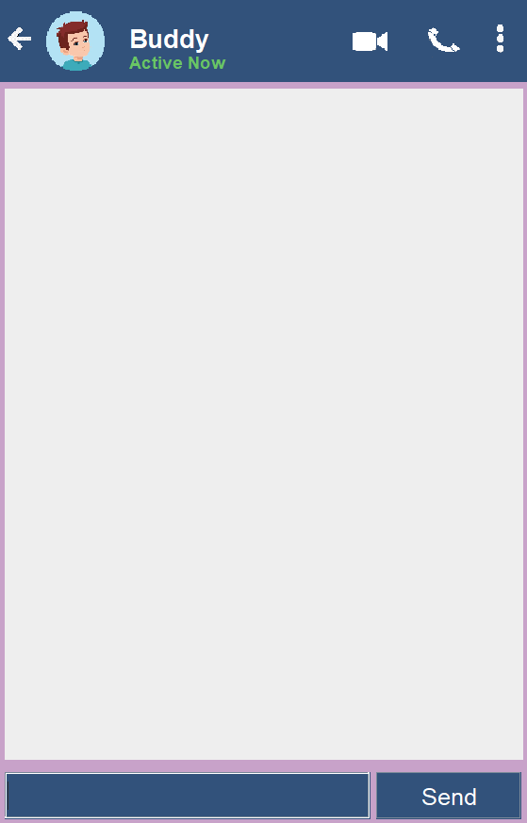 ***Server.java Client.java***

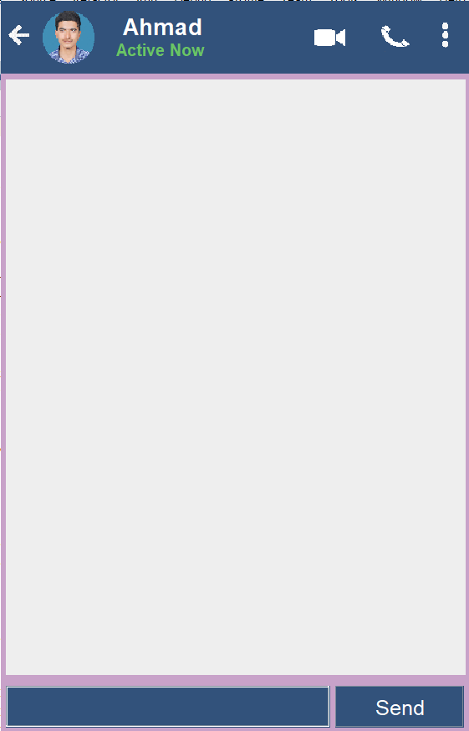

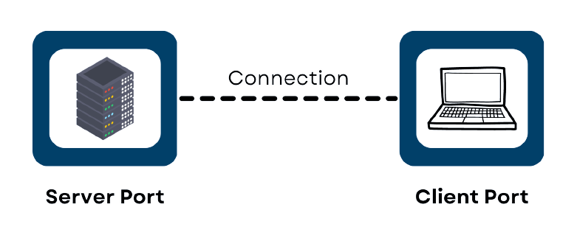

**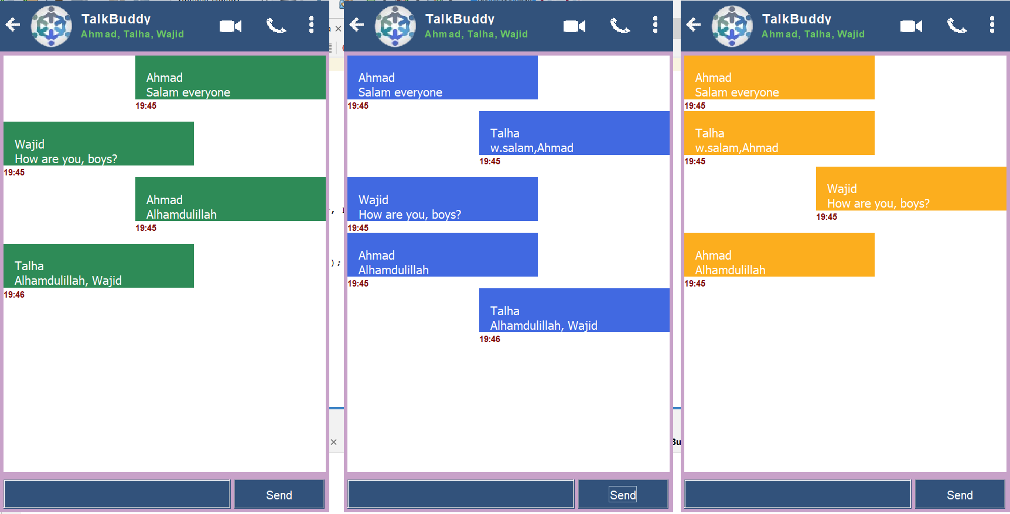*FirstUser.java SecondUser.java ThirdUser.java***

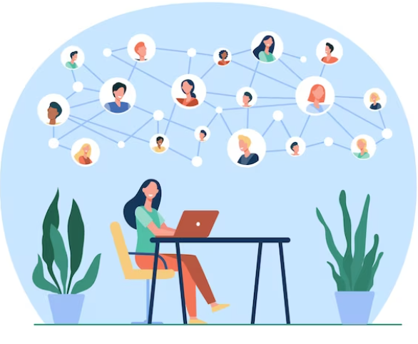

* Project Timeline:

The project timeline is as follows:

* Design phase: 1 week
* Implementation phase: 3 weeks
* Testing phase: 1 week
* Total project duration: 5 weeks
* Project Budget:

This project will be developed using open-source tools and software, therefore there will be no cost involved.

* Project Team:

The project will be developed by a team of one developer only.

* Future Enhancements:
* **Enhanced Audio and Video Calls:**

Implement support for group audio and video calls, allowing multiple users to participate in a single call simultaneously.

Integrate features such as screen sharing and call recording to enhance collaboration during calls.

* **AI-based Chat Assistant:**

Develop an AI-powered chat assistant that can provide personalized recommendations, suggest relevant content, and assist users with tasks such as setting reminders, scheduling events, or retrieving information from the web.

Incorporate natural language processing (NLP) techniques to improve the chat assistant's understanding of user queries and responses.

* **Voice Recognition and Control:**

Integrate voice recognition technology to enable hands-free control of the chat client.

Allow users to initiate actions, send messages, or navigate through the application using voice commands.

* **Advanced Chat Moderation**

Expand AI-based chat moderation capabilities to automatically detect and filter inappropriate content, spam, or abusive language in real-time.

Implement customizable moderation settings that allow users to adjust the level of content filtering based on their preferences.

* **Multi-platform Compatibility:**

Extend the chat client's compatibility to other platforms such as mobile devices (iOS and Android) and web browsers, enabling seamless communication across different devices and environments.

Develop dedicated mobile apps or web-based clients with responsive design for optimal user experience on various devices.

* **Integration with Third-party Services:**

Integrate with popular third-party services such as social media platforms, productivity tools, or cloud storage providers to enhance collaboration and streamline workflow within the chat client.

Allow users to access and share content from external services directly within the chat interface.

* **Enhanced Security Features:**

Implement end-to-end encryption for all communication channels to ensure the privacy and security of user data.

Introduce additional security measures such as two-factor authentication (2FA) and biometric authentication options for user login.

* **Customization and Personalization:**

Provide users with customization options to personalize their chat client experience, including themes, layouts, and notification preferences.

Incorporate machine learning algorithms to analyze user behavior and preferences, enabling personalized content recommendations and suggestions.

* Potential Questions:

**Q)** Can you share insights into the impact of implementing multithreading for group chatting functionality in terms of improving real-time message broadcasting efficiency? How did this feature contribute to a more dynamic and interactive chatting experience for users?

**Q)** What were the key factors that influenced the design and implementation of the splash window feature in your chat client? How did this introductory element contribute to setting the tone and user experience of the application?

Q) How can artificial intelligence and natural language processing techniques be leveraged to improve the chat client's functionality, such as providing automated suggestions, intelligent message filtering, or sentiment analysis?

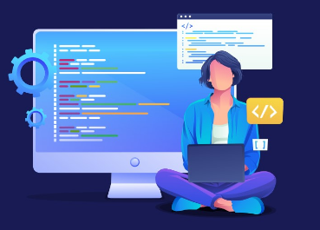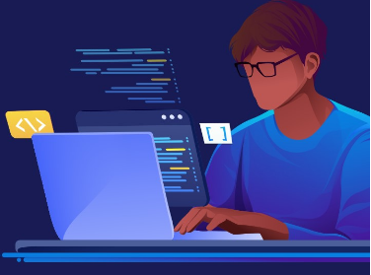

* Conclusion:

In a nutshell, TalkBuddy NetNexus represents a comprehensive and dynamic chat client that has evolved to meet the evolving needs of modern communication. Beginning with one-on-one private chatting capabilities, the project expanded to include a range of features designed to enhance user experience and interaction. From the convenience of a splash window introduction to the security of user authentication via MySQL Workbench, each element of the application has been meticulously crafted to ensure a seamless and engaging chatting experience. The addition of group chatting functionality, powered by multithreading concepts, further elevates the application, fostering collaborative discussions among users. Looking ahead, the potential for future enhancements, such as audio and video calls, AI-based features, and multi-language support, promises to continue pushing the boundaries of what is possible within the realm of chat clients. With its blend of innovation, functionality, and user-centric design, TalkBuddy NetNexus stands as a testament to the power of thoughtful development and a commitment to meeting the needs of users in an ever-changing digital landscape.

* Reference Citations:
* <https://www.codecademy.com/learn/learn-java>
* <https://www.geeksforgeeks.org/socket-programming-cc/>
* <https://www.edureka.co/blog/socket-programming-in-java/>
* <https://www.coursera.org/learn/computer-networking>
* <https://www.youtube.com/>
* <https://www.learnjavaonline.org/>
* <https://www.w3schools.com/>
* [https://stackify.com/java-tutorials//](https://stackify.com/java-tutorials/)
* <https://www.learnjavaonline.org/>
* <https://www.geeksforgeeks.org/computer-network-tutorials/>

***THE END***